Problem:

**While implementing a modal for post details in my social media app’s frontend, I used nested routes in React Router (e.g., /home → /home/:postId). When a user clicked a post, the modal with details opened as expected, but the feed behind it always jumped back to the top. This happened because the HomePage component (which contained both the feed and the <Outlet />) was being re-mounted every time the route changed, causing the scroll position to reset.  
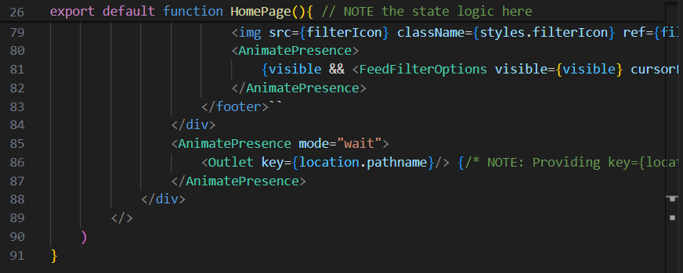  
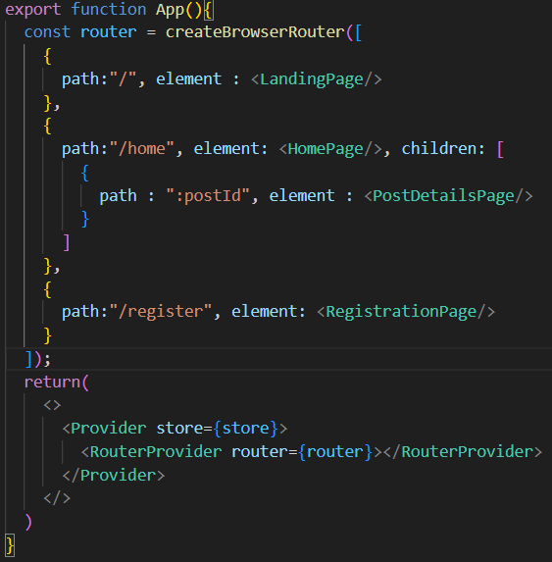**

Solution:

The fix was to use a **layout wrapper** (a parent layout route in React Router).

* I created a HomeLayout component that renders both the persistent HomePage (the feed) and an <Outlet /> for child routes.
* Then I moved the modal (PostDetailsPage) into the Outlet.
* Updated routes so that /home loads HomeLayout → HomePage, and /home/:postId loads HomeLayout → HomePage + PostDetailsPage (as a modal overlay).

This way:

* The feed (HomePage) **stays mounted** → scroll position is preserved.
* The modal (PostDetailsPage) **only overlays via the Outlet** → smooth animations with Framer Motion still work.  
  SCROLL